
Symbiosis Institute of Technology, Pune
Faculty of Engineering
CSE- Academic Year 2026-27
Java Programming – Lab Batch 2024-28
Lab Assignment No: - 27
Name of Student: Sanika Botre
PRN No.: 25070122063
Batch: 2025-29
Class: CSE A-2
Academic Year & Semester: 2026 & 3rd Semester
Date of Submission
Title of Assignment: Develop a Java application demonstrating socket programming for communication between a client and a server.
Learning Objectives: To establish communication between client and server using Java sockets.
Theory:
Socket programming enables communication between computers over a network using TCP/IP protocols. Java provides the Socket class for client-side communication and the ServerSocket class for server-side communication. A server listens for client requests on a specific port, while clients establish connections using the server's IP address and port number. Once connected, data is exchanged using input and output streams. Socket programming supports reliable communication between distributed systems and is widely used in chat applications, online gaming, file transfer systems, remote monitoring, and client-server architectures.
Practice questions
1. Create a simple client-server chat application using sockets
Code:
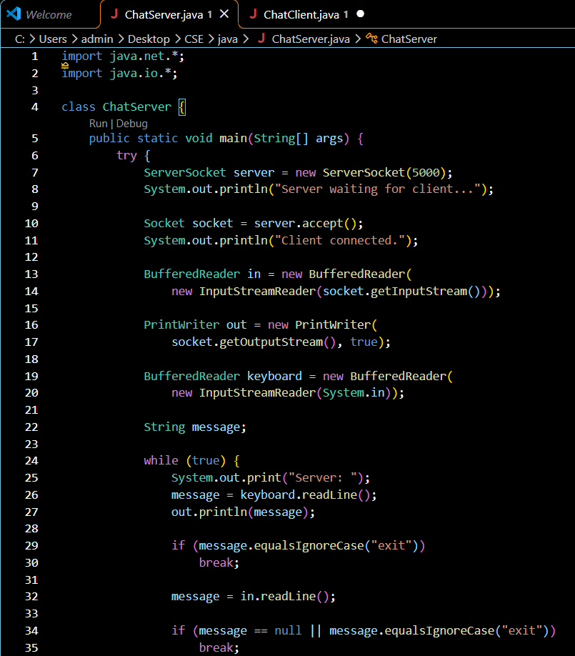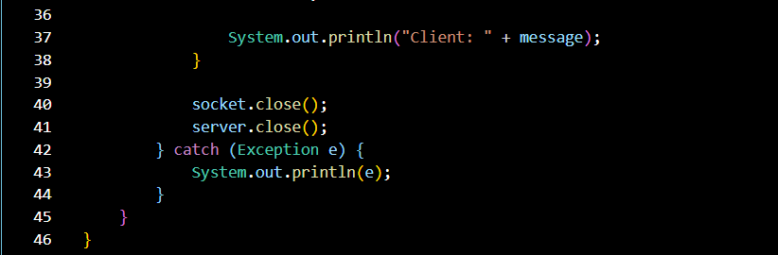
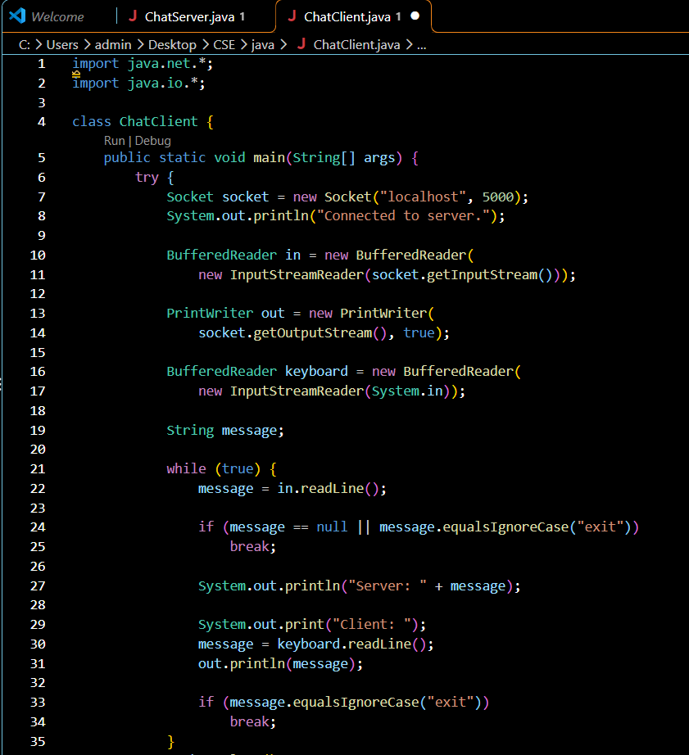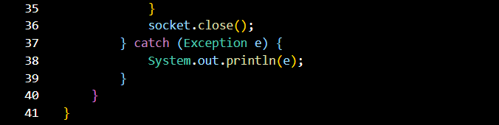

Output:
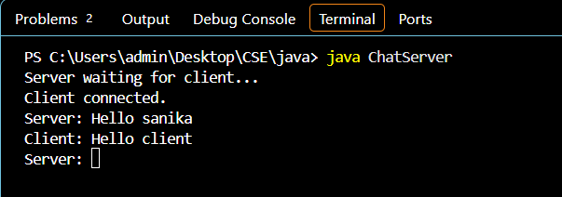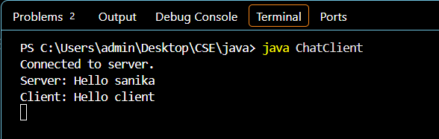

2. Create a Java program using socket programming where the client sends a message to the server, and the server returns the same message back (echo system).
Code:
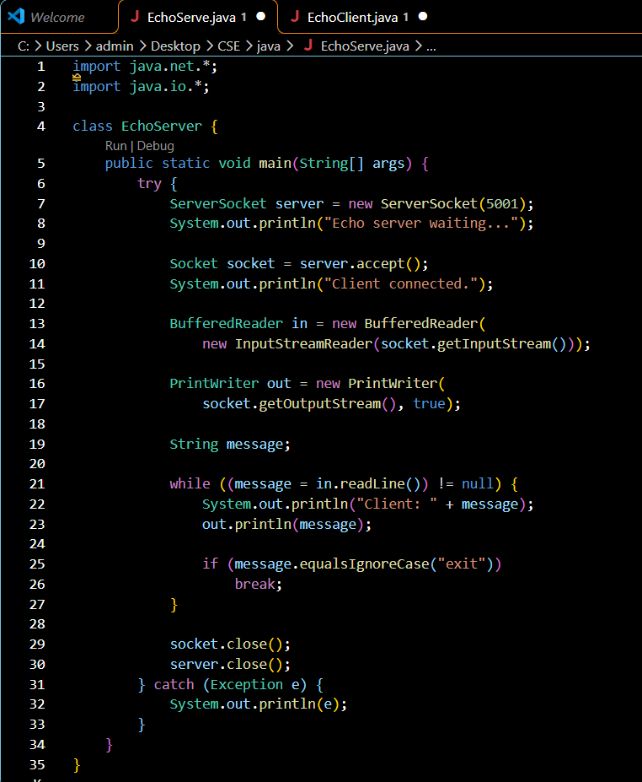
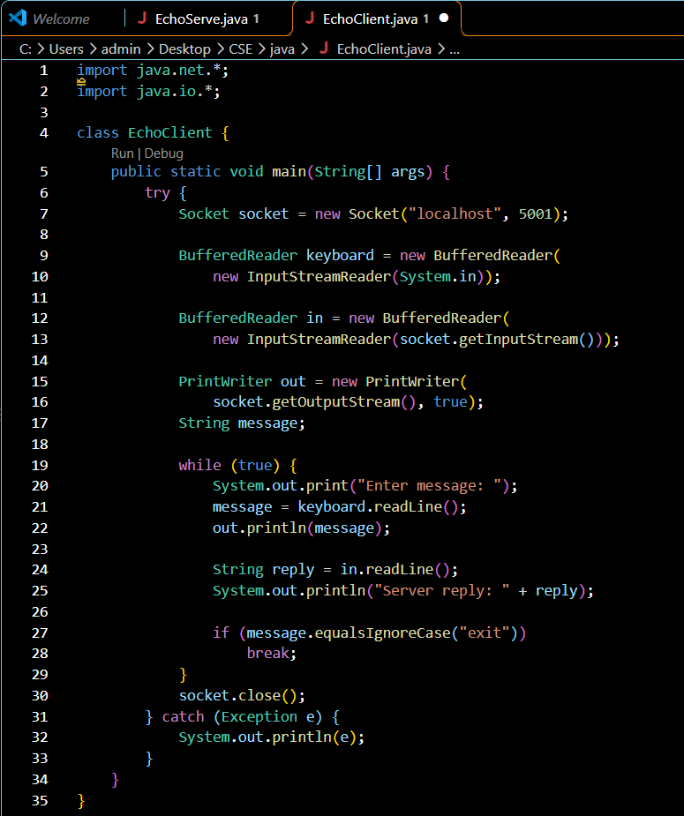

Output:
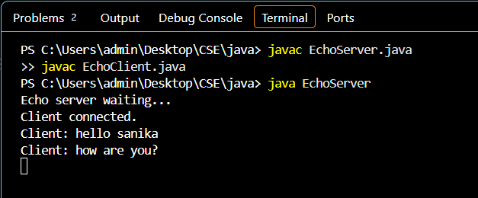
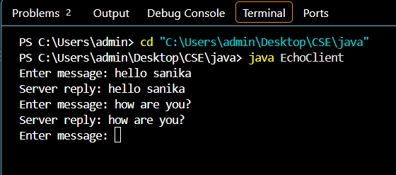

Conclusion
Thus, the echo system was successfully implemented using Java socket programming. The client sends a message to the server, and the server returns the same message to the client. This assignment helped in understanding client-server communication using the Socket and ServerSocket classes and input/output streams.

